Technical Datasheet 4G Gateway

Product Overview:-

The 4G Gateway is an advanced networking device designed to provide seamless connectivity and data management capabilities for various applications. With support for 4G LTE connectivity, cloud connectivity via MQTT protocol, and robust storage options, it offers a comprehensive solution for remote monitoring and control systems. Equipped with Modbus RS485 port and micro Sim compatibility, it caters to a wide range of industrial and IoT applications. The intuitive web-based UI interface allows for easy configuration and management, making it an ideal choice for both professionals and enthusiasts.
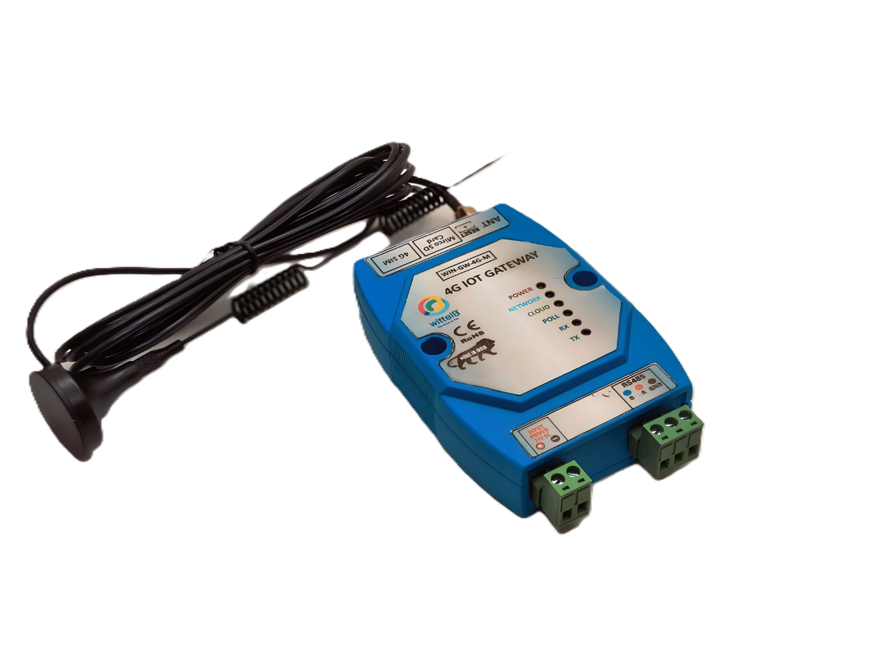

Specifications

General:-
•4G LTE Connectivity: Utilizes 4G LTE technology for reliable and high-speed internet access. If 4G is not available, the system automatically switches to Wi-Fi. If both 4G and Wi-Fi are unavailable, the data is securely stored in the SD card for later upload.
•Cloud Connectivity (MQTT): Seamlessly connects to cloud platforms using the MQTT protocol for efficient data transmission and management.
•Event Storage: Offers on board event storage, capable of storing up to 50,000 events or more. Includes an external memory card slot for easy data retrieval in the event of 4G network issues.
•Modbus RS485 Port: Features 1 port of Modbus RS485 for integration with industrial control systems and sensors.
•GPS Location Data: Provides GPS location data for monitoring of remote equipment.
•Micro Sim Compatibility: Supports micro-Sim card for flexible and convenient connectivity option.
•Web-based UI Interface: Intuitive web-based user interface for easy configuration, monitoring, and management.
•Dimensions: 110 mm L x 110 mm B x 50 mm H.
•Power: Input Power – 15-40 VDC, Typical – 12V DC @ 150mA.
•Operating Temperature: 0 – 60C (32 ~ 140F).
•Storage Temperature: 20 - 70C (-4 ~ 158F).
•Storage Humidity: 5 ~ 95 % RH, non – Condensing.

LED Indicators:-
• POWER: Device power status.
• NETWORK: Indicates 4G/Wi-Fi network connectivity.
• CLOUD: Shows MQTT cloud connection status.
• POLL: POLL/WI-FI: Indicates Modbus polling activity / Wi-Fi mode
• RX: Data received from RS485.
• TX: Data transmitted to RS485.
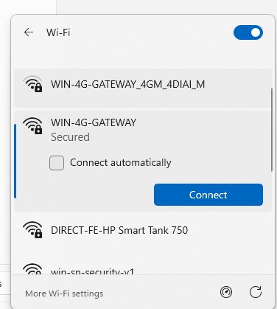

Configuration Settings:
- Power up the module by connecting a 12 V DC supply.
- Insert the SIM card into the designated slot.
- Place the Micro SD card into its designated slot.
- Connect MODBUS RTU Multiple Slave devices (up to 31) to the A & B Terminal
Of Module.
- Access the module's configuration hotspot
(ID: WIN-4G-GATEWAY, PASS: 123456789).
- Default IP Address of Module is “192.168.1.100/cpp1”.
- Upon entering the provided IP address, a configuration webpage
Pages will be accessible.

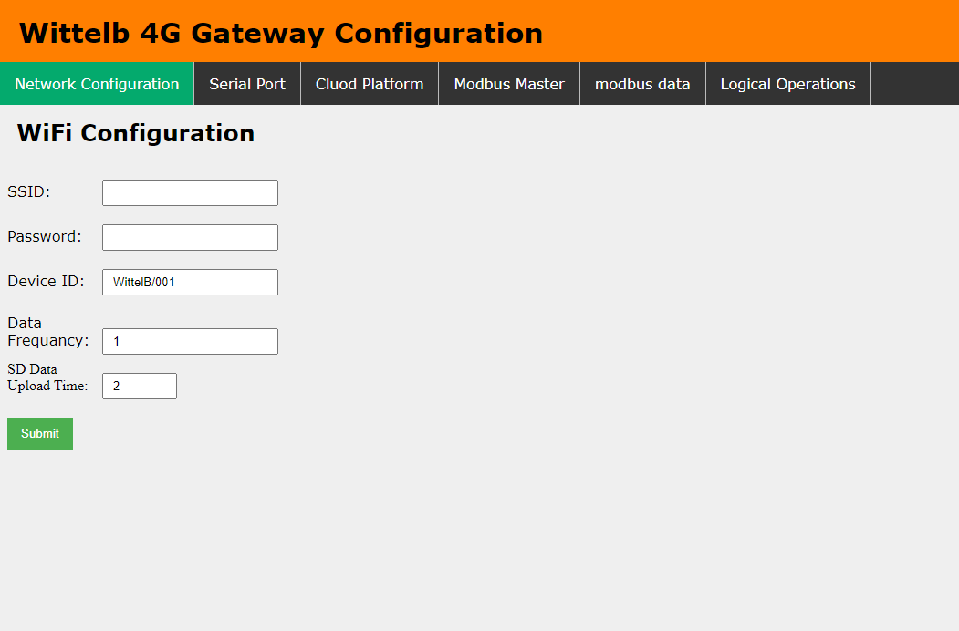
Page 1: -

- Enter Device ID (Should be unique for every device).
- Enter data frequency in min to receive data on cloud.
- Enter time to upload SD card data to cloud.

Page 2:-
On second page you can set device Baud Rate (9600 / 19200 / 38400 / 57600 / 115200), Data Bits (5 / 6 / 7 / 8), Parity (None / Odd / Even), and Stop Bits (1 / 2) for RS485 Communication
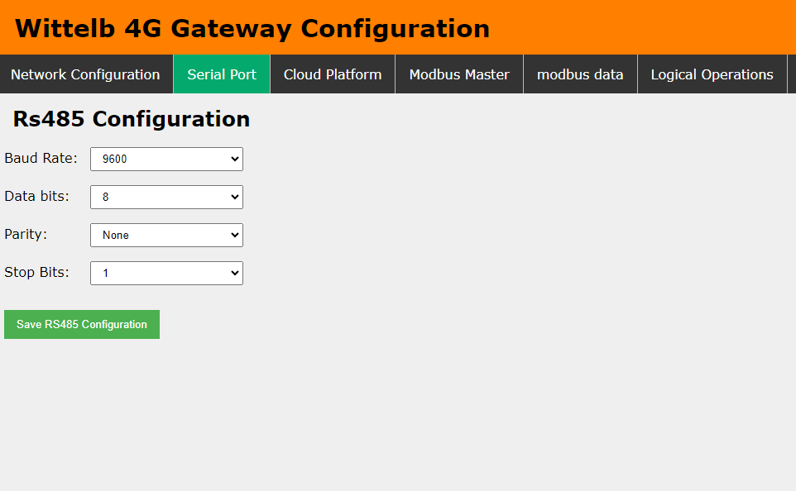

Page 3:-
      - Navigate to page 3 on the cloud platform.
      - Input the Host IP or Domain.
      - Enter the port Number.
      - Enter the topics for publishing and receiving messages.
      - Provide a username and password if required.
      - Allow a few seconds for the module to restart and establish a connection to
MQTT.
      - Select Wifi and 4G from Which Source you need to send data over MQTT

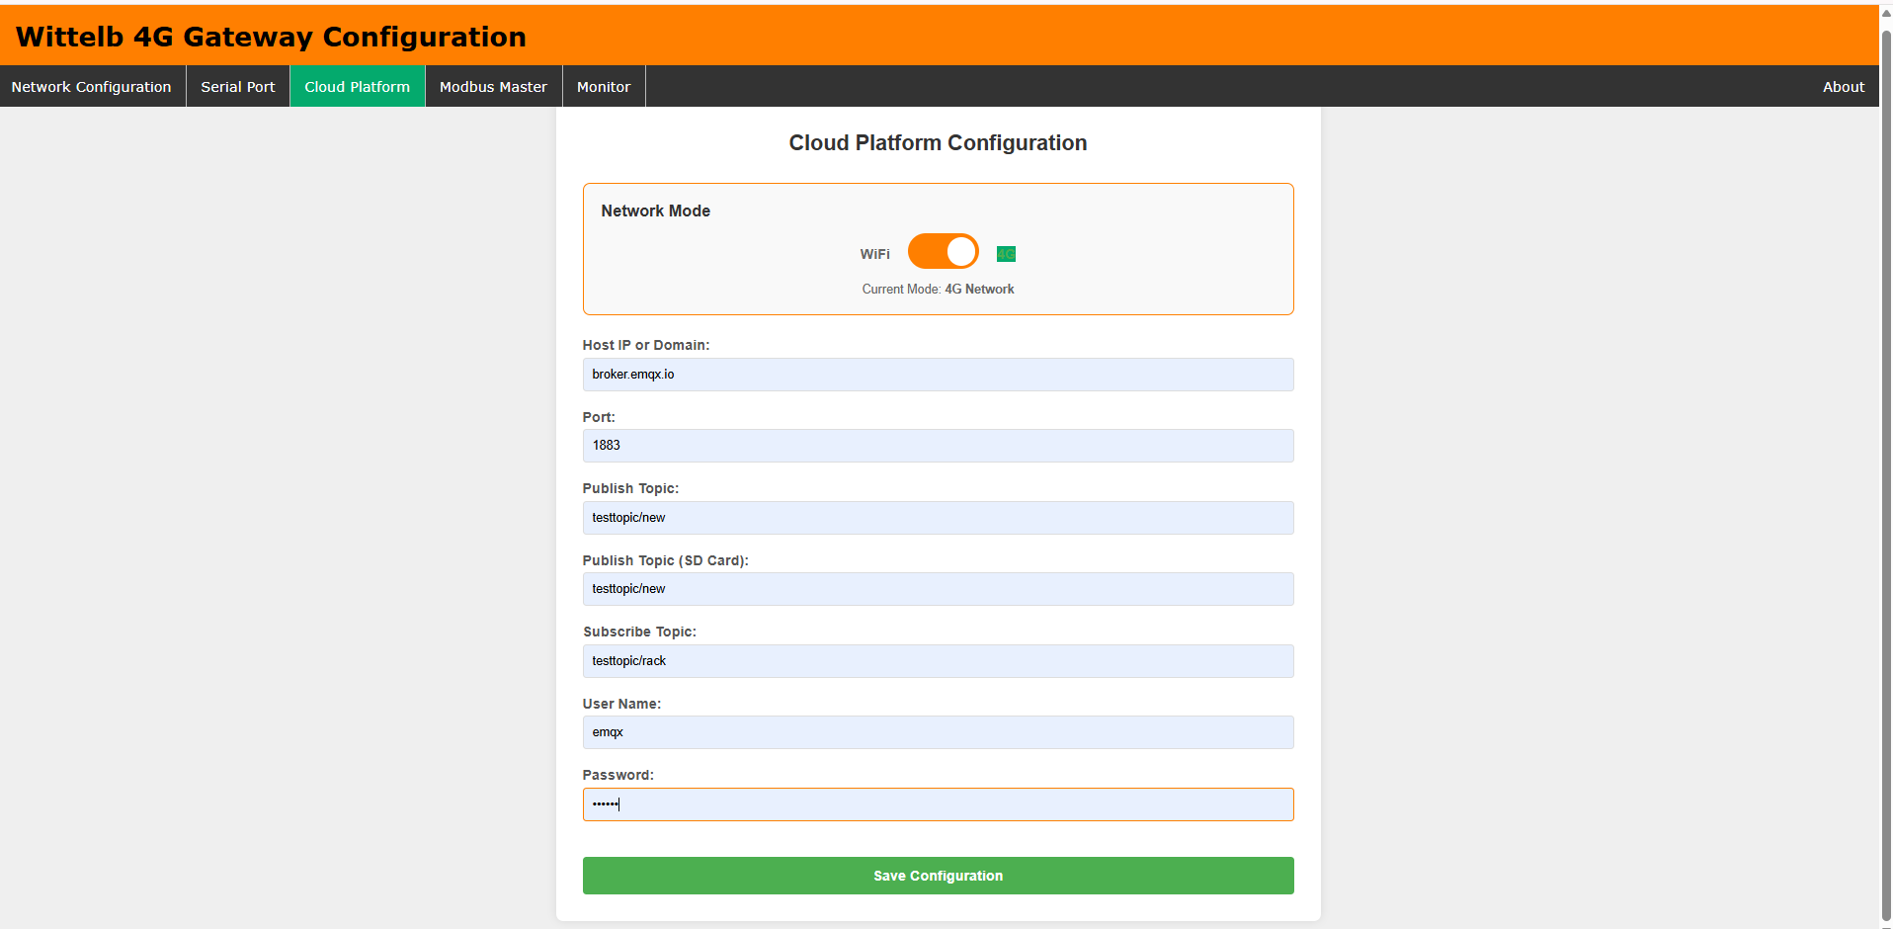

Page 4:-
- Go to page 4 on the Modbus Master interface.
- Input the name and slave address for the designated slave.
- Specify the register address from which you want to read slave data.
- You can enter only the Register which you need to read.
- Select the Data Type: UINT16, Float32 Big Endian, Float32 Little Endian, Float32 BE Byte Swap, or Float32 LE Byte Swap.
- Enter the function code corresponding to the desired slave.
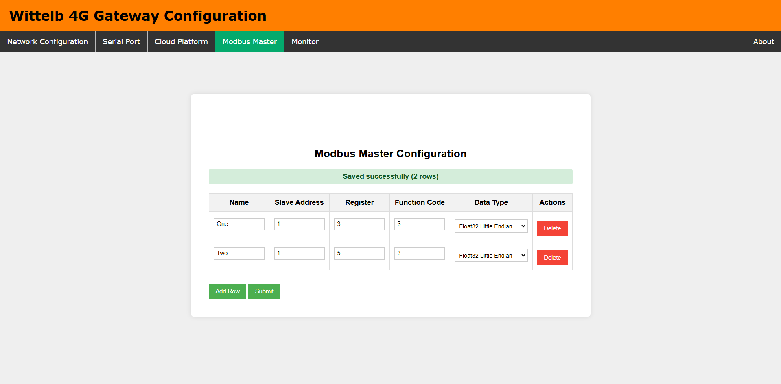

Page5:-
- On page 5 (Monitor), view live Modbus register values for all configured entries.
- Table auto-refreshes every 7 seconds showing: Slave Address, Register, Function Code, Tag Name, Data Type, Live Value, and Status (OK / FAIL)
- Use Slave Address and Register filter fields to narrow down the live view.

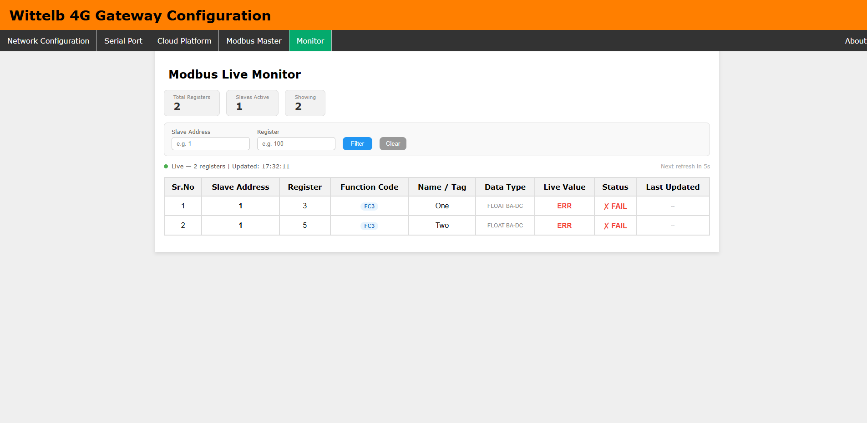

4G Gateway connection Diagram: -

RESET
SD Card Slot

ANTENNA
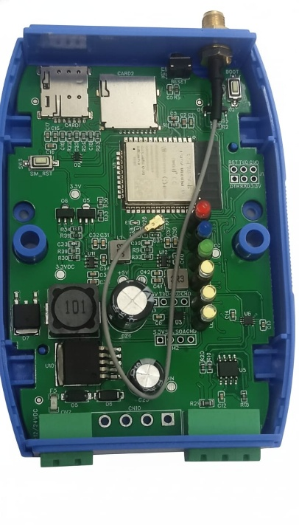
Sim Card Slot

POWER
NETWORK
CLOUD
POLL/WI-FI
RX
TX
Modbus [A-B]

Power Connection and Power Led

Additional Features: -
Communication ports are isolated
Input power reverse polarity safety
ESD Safety IEC 61000-4-2, ± 30KV contact, ± 30KV air
EFT IEC 61000-4-4, 50A (5/50ms) 400V isolation.

Contact us: -
Augmatic Technologies Pvt. Ltd.,
Plot no 6, Shah Industrial Estate II,
Kotambi,
Vadodara – 391510.
Email – Sales@wittelb.com

